March 14, 2007
Clarification of President Leland’s Action on Motion (0607.US. 004.P)
Library Collection Budget Support

I recommend that the Senate reconsider this policy for several reasons.
First, some policy language changes are needed prior to implementation and
there are other matters that need to be reviewed to determine if the policy
can be reliably implemented. Second, there are some broader issues
regarding appropriate uses of student fees that the Senate may wish to
debate, with input from the Budget and Planning Committee.

Policy Language and Implementation Issues

1) The policy needs to refer to expenditures rather than budgets. These can
be quite different and I believe that total collections expenditures is the
relevant measure.

2) The policy needs to refer to expenditures from all funding sources. The
figures provided to the University Services Committee did not include
expenditures from the library endowment fund.

3) The policy needs to refer either to expenditures per FTE or expenditures
per headcount. I recommend FTE.

4) The policy statement provides no guidance for selecting among competing
fee requests should the total student fee requests from multiple university
departments exceed "the library collections budget per student on the
average level of all COPLAC institutions."

5) Currently we do not have accurate COPLAC comparisons regarding total
library collections expenditures. The information compiled by COPLAC and
shared the University Services committee only includes expenditures from
state revenue. We believe we can get the data if COPLAC institutions
cooperate with us on this, but still don't know for certain.

Broader Issues

Library expenditures are a huge issue across the USG. I've attached some
graphs that will show you how GCSU stacks up based on general revenue
expenditures only. Our total general revenue library expenditures per FTE
student are just slightly above the state and slightly below the regional
university sectors, but our total library personnel expenditures are
considerably above the state and regional university sectors. This may
indicate that other institutions in our USG sector are finding ways to
devote a greater percent of total library expenditures to collections. This
needs further review, which will require disaggregating the data. (Note that
the true expenditure picture may differ when expenditures from all funding
sources are included,)

GCSU falls behind COPLAC peers in all funding categories for which we have
data, expect for instruction. (The other categories are academic support,
institutional support, student services, and other core expenses.) Given
this situation, I have some concerns about establishing a precedent for
using student fees to bring GCSU up to COPLAC averages, and I strongly
suspect that the Board of Regents may share this concern. (The BOR does not
approve course fees but the USO requires us to report these fees.) Perhaps
there is some language that could be crafted that singles out the library
collection as a unique category. Perhaps we could consider limiting the
library course fees to direct support of journals that students must use as
part of course requirements and that can't otherwise be supported (i.e.,
index the course fee more closely to a particular course, so that it
functions more like a course fee and less as a tax to support to general
library collection.)

------ End of Forwarded Message

------ End of Forwarded Message

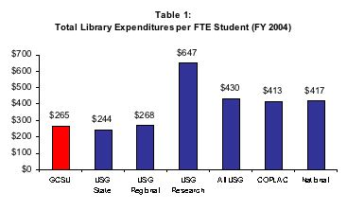
Image[2][1]1.jpg

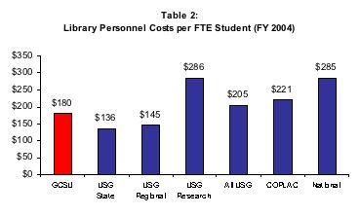
Image[3][1]1.jpg

